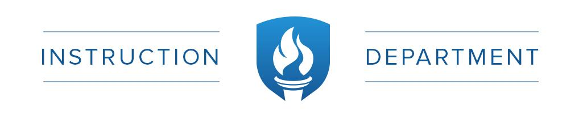
Early Entrance to First Grade Approval Checklist
For Students with Kindergarten Experience (Non-Public)

Child’s name _______
(First) (Middle) (Last)

Your Child’s Home School: __________________________________________________________

Name of Non-Public school where child attended Kindergarten: _____________________________

To qualify for early entrance into first grade all of the following criteria must be met. Please indicate in the space provided either a “Yes” the child has met this criteria, or “No” the child has not met this criteria:

- _______ Child turns 6 between September 1st, and December 31st of the school year they expect to enroll.

2. ________ Parent provides birth certificate and completed Early Entrance Referral form by due date.

3. Parent provides evidence that the child has successfully completed a kindergarten program in a non-public school and evidence that the curriculum of the kindergarten program is aligned to District 59 curriculum and taught by an appropriately licensed teacher by bringing copies of:

Report Cards
Teacher Recommendation
Assessment information

District 59 reserves the right to administer further assessments as needed.

4. _______ Child demonstrates above average social-emotional development by interviews, observation, adaptive behavior indicators, and/or professional judgment by a District 59 staff member.

5. _______ Child scored at/or above the 85th percentile nationally as obtained by a recognized individually administered District 59 achievement test in both reading and math.

6. _______ The District Review Team and/or Principal has reviewed the above information and supports early entrance into first grade for a trial period of 20 days.

Approved by: __________________________________________Date _____________________

